ASSIGNMENT 1
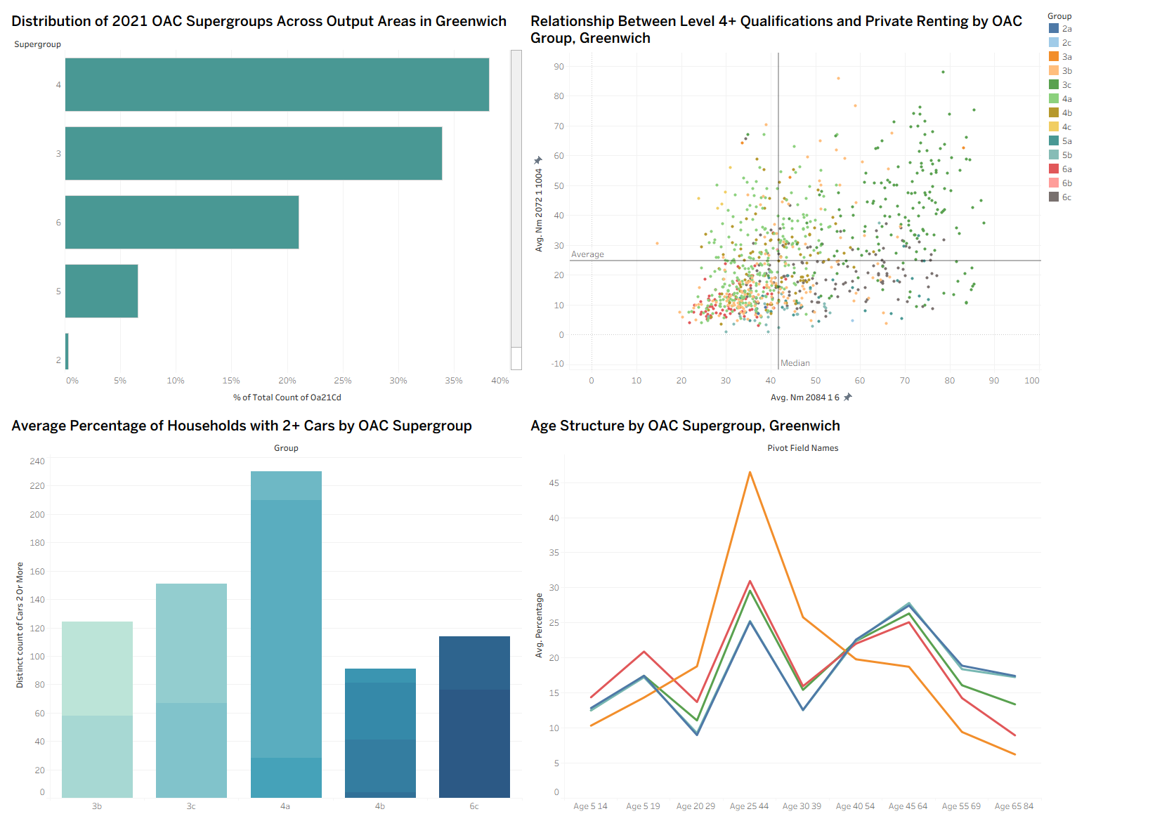
Message and Audience :
Using the 2021 Output Area Classification (OAC), this visualization looks at sociodemographic differences between Greenwich's different neighbourhood types. It draws attention to how different supergroups are more or less common in the borough and how they are linked to differences in age distribution, private renting, educational attainment, and car ownership. The main takeaway is that Greenwich has unique neighborhood profiles that are distinguished by various combinations of housing tenure, educational attainment, and demographic makeup. The dashboard is designed for researchers, urban planners, and local policymakers who want to learn more about the socioeconomic structure of small areas and how the OAC captures significant spatial differentiation within a London borough.
Encoding Choices :
Four complementary charts are combined on the dashboard to offer relational analysis as well as an overview. The first chart encodes the percentage of Output Areas allocated to each OAC supergroup using horizontal bar marks. Accurate comparison is supported by position along a common baseline and bar lengthInstead of using raw counts, proportional representation is ensured by calculating the percentage of total from unique Output Area codes.
A scatterplot is used in the second chart to illustrate the connection between private renting and Level 4+ qualifications. Encoded by position along two continuous axes that represent percentage values, each point represents a 2021 Output Area. OAC group membership is encoded by color, allowing for the visual evaluation of clustering patterns across different types of neighborhoods. Quadrant structure is provided by median reference lines without suggesting causation.
The third chart uses vertical bars to show the average percentage of households with two or more cars by supergroup. To prevent distortions brought on by different group sizes, mean percentages are utilized rather than counts.
Lastly, the age distribution across supergroups is shown in a line chart. To maintain their ordinal nature, age bands are arranged along the x-axis, and supergroups are distinguished by color. For A3 print output, legibility and graphical integrity are supported by percentage scales, consistent color usage, and minimal visual clutter in all charts .

Critical Evaluation :
In order to present both compositional and relational perspectives on the neighborhood structure of Greenwich, the dashboard skillfully combines a variety of chart types. Percentage transformations and position-based encodings support graphical accuracy standards and improve comparability. Interpretability is supported by using supergroups as a consistent organizing dimension. However, the number of Output Areas may cause overplotting in the scatterplot, and the categorical color encoding necessitates careful interpretation of the legend. Furthermore, spatial contiguity is not directly depicted on the dashboard, even though maps are avoided as necessary. All things considered, the design presents a cogent story of sociodemographic differentiation while striking a balance between simplicity and complexity.

